**PRESS RELEASE: FOR IMMEDIATE RELEASE**

**Community Gatherings to Commemorate Pandemic Begin in Dumfries and Galloway**

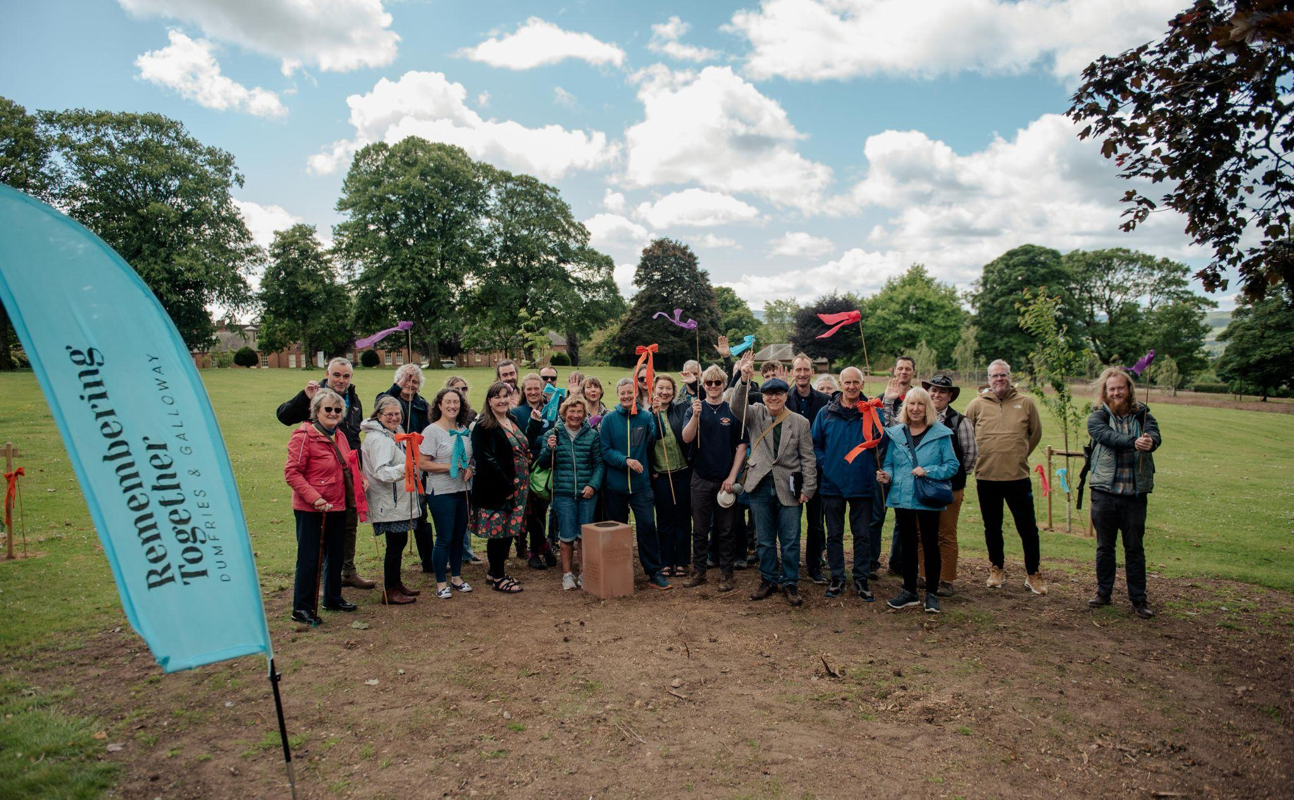

**Communities across Dumfries and Galloway are set to gather as part of Remembering Together, a national project to honour those lost to COVID in the region.**

**Details on future community gathering events below:**

**Fri 14th June – Sanquhar, Bells Crescent Park (11am - 2pm) – photocall at 11:15**

**Thurs 20 June – Moffat, Moffat Community Nature Reserve (6pm - 8pm)**

**Thurs 27 June – Castle Douglas, NTS Threave Nature Reserve, (6pm -8pm)**

**Sat 29 June – Stranraer, Galloway Community Hospital (11am - 3pm)**

**To confirm your attendance at any of these dates, please email**

[**ewan.shand@premiercomms.com**](mailto:ewan.shand@premiercomms.com)

Over the past two years, **DG Unlimited** and **Dumfries and Galloway Council** have been working in collaboration with **greenspace scotland** and Commissioned Artists **t s Beall** and **Katie Anderson** to deliver Dumfries and Galloway’s contribution to Remembering Together, a national project that seeks to give each of Scotland’s 32 local authorities the chance to reflect their unique experience of the Covid-19 pandemic. During March and April 2024, the project team, alongside local community groups and families affected by the pandemic, planted over 400 trees at five locations across the region as part of a **Dispersed Memorial Forest** – at Castle Douglas, Dumfries, Moffat, Sanquhar, and Stranraer. The number of trees planted corresponds to the number of people who died from Covid-19 in Dumfries and Galloway.

Now as the project enters its final stages, community gathering events will take place at each location in June, with activities including walks, story sharing, music and food. In addition, these gatherings will also see the installation of bespoke sculptural markers – including handwritten messages honouring lost loved ones, that share stories of loss and resilience gathered from individuals across the region during Phase 1 of the project. These handwritten words will be memorialised via inscribed text onto sculptural sandstone markers, and cast in bronze by artist Katie Anderson. The project will also include an online archive sharing stories from those involved in the project, which is set to launch in July.

These gatherings also have heightened resonance during #Carer’s Week (10 - 16 June), as the project worked diligently to connect with unpaid carers, and highlight their voices and experiences during lockdown -- throughout the development and co-creation of the memorial forest

Communities are now set to come together in celebration of The Dispersed Memorial Forest as a new living memorial, with each tree planted honouring someone lost to COVID in the region, as the artists hope to highlight “the different ways communities grew together over the pandemic”. It is hoped that this memorial forest will provide not just a vital place of healing for the community, but also an important statement of intent for increasing biodiversity and sustainable development. Members of the public across Dumfries and Galloway are warmly invited to the free community gathering events scheduled in Sanquhar, Moffat, Castle Douglas, and Stranraer.

**Commissioned Artists t s Beall and Katie Anderson said**, “We want to warmly invite members of the public to join us at the different Gathering events across Dumfries and Galloway as we mark the opening of The Dispersed Memorial Forest. It’s been an honour to speak to so many people over the past two years, as we developed the Community Covid Memorial for the region.

We’ve worked to highlight the experiences and voices of unpaid carers and other key workers, alongside young people and other community groups throughout the project – and their handwritten messages and stories are included both in the sculptural markers at each Memorial Forest site, and the upcoming online archive.”

**Fiona Barr, Adult Carers Support Worker at Dumfries and Galloway Carers Centre said**, “It has been a great privilege and an honor to have been involved with the project from the very early days. As an organization we feel strongly that Carers views are taken into account and that they “have a voice”. We were able to consult with Carers across the region in person and virtually to ask their opinion and hear their own personal stories around the Pandemic. All this has been recognized and added into the wonderful memorial that we have today in Dumfries and Galloway.

Working with Katie and t s has been such a lovely experience and our Carers really have enjoyed the conversations and projects that they were invited to take part in. As this is National Carers week it is so important that we make sure that our Carers are recognized for all that they do and contribute to the community.”

**John Saich, Remembering Together Co-lead at greenspace scotland said,** “The response across the country to Remembering Together has been extraordinarily moving, as artists have worked closely with communities, co-creating ideas around what have often been very personal stories of grief and loss. As elsewhere, our artists and delivery partners in Dumfries and Galloway have been exceptional in their commitment, taking care to reflect sensitively on the trust communities have placed in the project. The Dispersed Memorial Forest is a remarkable expression of that trust, and we are deeply grateful for the support shown by so many individuals, community groups and organisations in the region.”

**Frank Hayes, Chair of DG Unlimited, Lead Partner, Remembering Together Steering Group**

**said**, "It's fantastic to see The Dispersed Memorial Forest at completion. From the early sketches and conversations, all of us on the Steering Group knew this was a special and important project. Now, the trees are planted and we have a Dispersed Forest around the region we can all enjoy and visit as a memorial to those we lost during the pandemic. Congratulations to the entire team, communities and contributors on a great job. A heartfelt thanks to all our partners, and to greenspace scotland and the Scottish Government for making this possible in our region."

**Remembering Together Dumfries and Galloway** is commissioned by **greenspace scotland**, **DG Unlimited**, and **Dumfries and Galloway Council** with funding from the Scottish Government.

[Linktr.ee/rememberingtogetherdg](https://linktr.ee/rememberingtogetherdg) | fb & insta [@rememberingtogetherdg](https://www.facebook.com/rememberingtogetherdg) | twitterX [@covidmemorialdg](https://twitter.com/covidmemorialdg)

========= ENDS ========

**NOTES FOR EDITORS**

**Images** from Phase 1 of the Project available [**here**](https://drive.google.com/drive/folders/17GB0DSns9WvUXcdw5SOhG18F0NBsECTG?usp=drive_link)and Dumfries tree planting events[**here**](https://drive.google.com/drive/folders/1byk-K17YqtX-k4QpqIan4blaRdMMqRjQ?usp=drive_link)

**Sites for the Dispersed Memorial Forest and Partners**

**Stranraer**: Galloway Community Hospital, Stranraer DG9 7DQ

Working with site owner/Local Partner NHS D&G and GCH Garden Volunteers (Incredible Edibles Stranraer), D&G Carers Stranraer, individual NHS staff and community members

– – – – – – – –

**Castle Douglas**: NTS Threave Nature Reserve, Castle Douglas DG7 1TJ.

Working with site owner/Local Partner NTS Threave Nature Reserve, Castle Douglas Development Forum (CDDF), and individual community members

– – – – – – – –

**Sanquhar**: Bells Crescent Park, Sanquhar DG4 6AL.

Working with site owners and Sanquhar Enterprise, Sanquhar Community Council, A the Airts, Dumfries and Galloway Council and individual community members

– – – – – – – –

**Moffat**: Moffat Community Nature Reserve, Moffat DG10 9SF

Working with Site Owner and Local Partner Moffat Community Nature Reserve and their volunteers, Borders Forest Trust and their volunteers, and individual community members

More information on the Scotland-wide Remembering Together project is available at: <https://www.rememberingtogether.scot/>

Information on the Dumfries and Galloway portion of the project can be found at: <https://www.rememberingtogether.scot/dumfries-galloway>

Updates on Remembering Together Dumfries and Galloway are available on the project’s social media:

* FB [@rememberingtogetherdg](https://www.facebook.com/rememberingtogetherdg)
* insta [@rememberingtogetherdg](https://www.instagram.com/rememberingtogetherdg/)
* twitter [@covidmemorialdg](https://twitter.com/covidmemorialdg)

**Remembering Together Dumfries and Galloway** is commissioned by [*greenspace scotland*](https://www.greenspacescotland.org.uk/remembering-together), DG Unlimited, and Dumfries and Galloway Council with funding from the Scottish Government.

For all press enquiries please contact [ewan.shand@premiercomms.com](mailto:ewan.shand@premiercomms.com) and [chris.boyd@premiercomms.com](mailto:chris.boyd@premiercomms.com)